**5) LAB EXERCISE**

Network Topology:

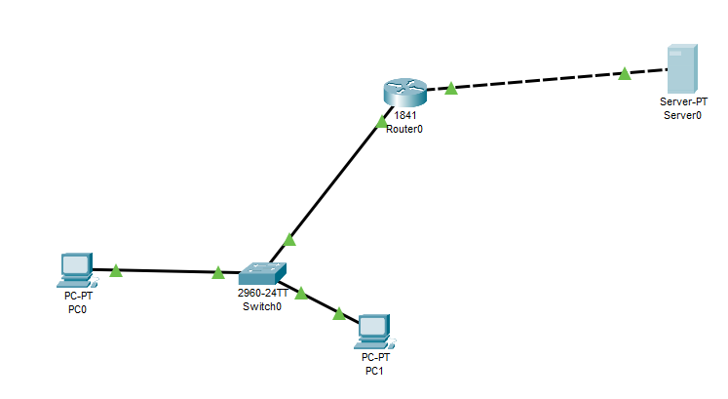

Router Exercise:

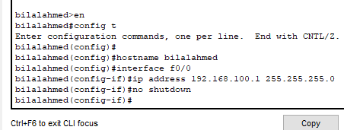

Running simulation screenshot:

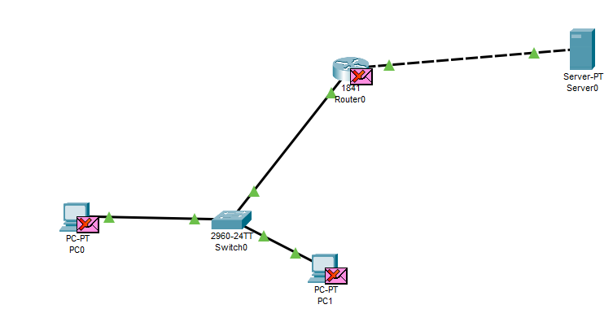

Importing HTTP file

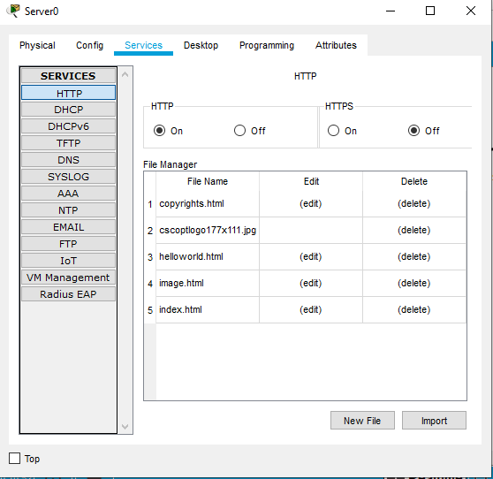

Pinging server successfully

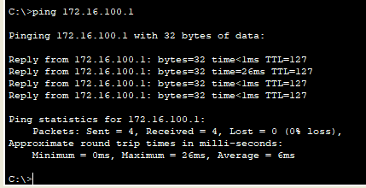

Web App working successfully



Running simulation successfully

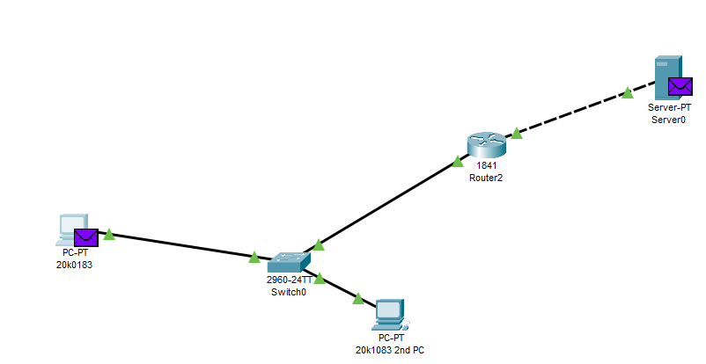

Event listener Response

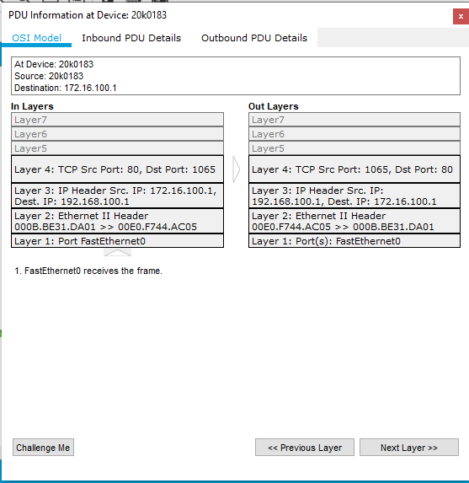

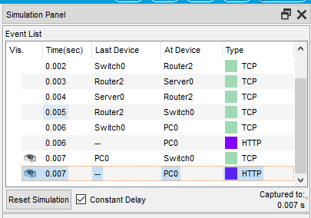

**Difference between http and https:**

HTTPS is HTTP with encryption and verification. The only difference between the two protocols is that HTTPS uses TLS (SSL) to encrypt normal HTTP requests and responses, and to digitally sign those requests and responses

**6) Wire Shark**

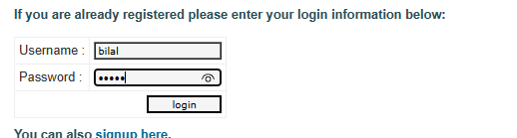

Filtering http request

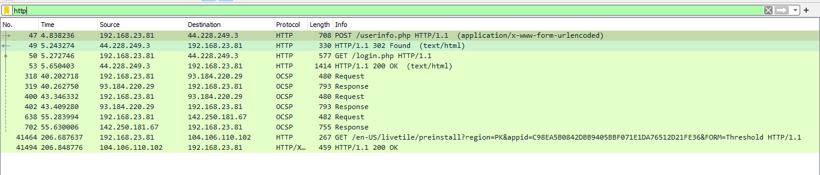

Username and password captured by POST method



https TLS encrypted data

